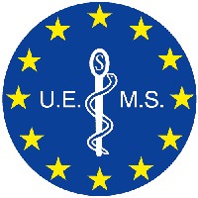

EACCME
European Accreditation Council for Continuing Medical Education

Certificate
SSIEM Symposium YYYY
Place Name, Country, Date dd/mm/yyyy to dd/mm/yyyy

has been accredited by the European Accreditation Council for Continuing Medical Education (EACCME®)
for a maximum of Number European CME credits (ECMEC®s).

Each medical specialist should claim only those credits that he/she actually spent in the educational activity.

The EACCME® is an institution of the European Union of Medical Specialists (UEMS), www.uems.net.
Through an agreement between the European Union of Medical Specialists and the American Medical Association, physicians may convert EACCME® credits to an equivalent number of AMA PRA Category 1 Credits™. Information on the process to convert EACCME® credits to AMA credits can be found at www.ama-assn.org/education/earn-credit-participation-international-activities.

Live educational activities occurring outside of Canada, recognised by the UEMS-EACCME® for ECMEC® credits are deemed to be Accredited Group Learning Activities (Section 1) as defined by the Maintenance of Certification Program of the Royal College of Physicians and Surgeons of Canada.

Delegate Title First Name Last Name

has been awarded [xxx] European CME Credits (ECMEC®s)
for his/her attendance at this event

